Certificate of Analysis

General properties:
Name： PLGA2000-PEG3400-COOH, PLGA:50/50
Molecular Weight： PEG MW:3400, PLGA MW:2000
Cat.#： R-P-103002
Lot.#： RP016016
Manufacture Date： 2016.05.16
Date of Analysis： 2016.05.16
Recommended Retest date： 2017.05.16
Stability： 12 months
Storage： -20°C in the dark

Structure

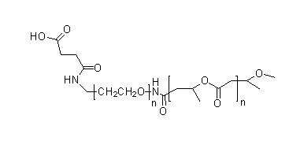

Items | Specification | Results
Appearance | White/ Off-white solid | Off-white solid
¹H NMR | Identical to the structure | Identical to the structure
Foreign Material | None | None
Substitution | ＞90% | 90%
Report Date: 2016.05.16

This product is for research use only, Not for human or animal use

